**SCENARIO 1: Create Linux VM and Store Daily Logs**

**🔷 Objective:**

Log daily user activity and store it as a log file.

**💡 Architecture:**

User Activity → Linux VM → Cron Job → /var/logs/auth.log-<date>.log

**🛠️ Implementation:**

* Provision a **Linux VM : poc-vm** from Azure.

* **Allow Inbound and Outbound Rules for VM**

* + - **Access the VM using Putty**
    - 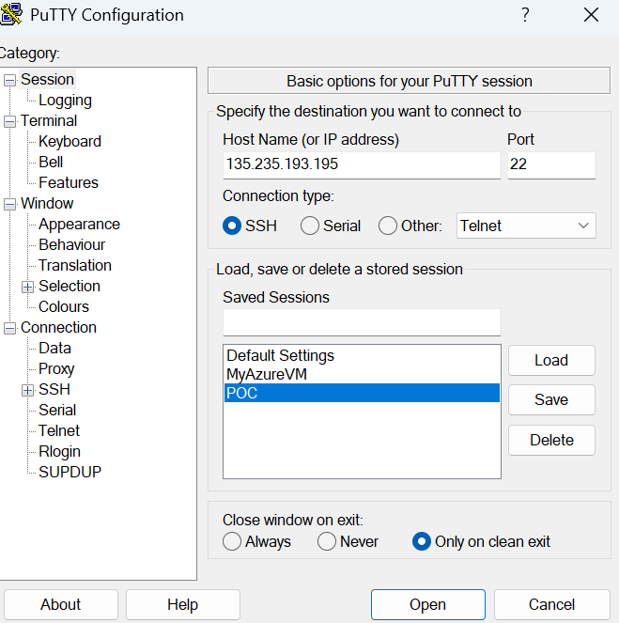
    - 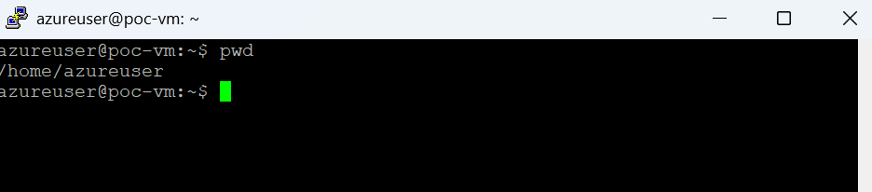
* **Use crontab to run it daily:**

# 0 2,14 * * * sudo cp -f /var/log/auth.log /home/azureuser/logfile.log (Executes twice in a day at 2 am and 2 pm)

